CS 330 Intro to the Design and Analysis of Algorithms
Homework 4
(20 pts)

1. Let G be a graph where every edge has a distinct weight. Show
that:
a. The edge with the smallest edge weight is in the minimum spanning tree.

b. There is only one, unique minimum spanning tree in this case. [3 points]

2. In the weighted graph from the figure below, find the sequence of edge weights
selected when:

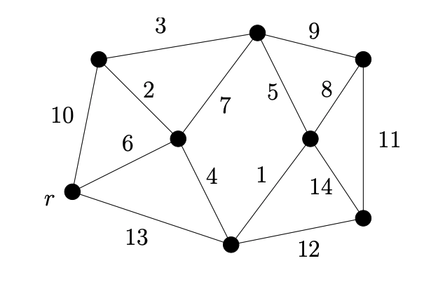

- Kruskal’s algorithm is run.

- Prim’s algorithm is run. [4 points]

3. Explain the differences between P, NP, and NP-Complete problems. Find a topological ordering for the following directed acyclic graph: [4 points]

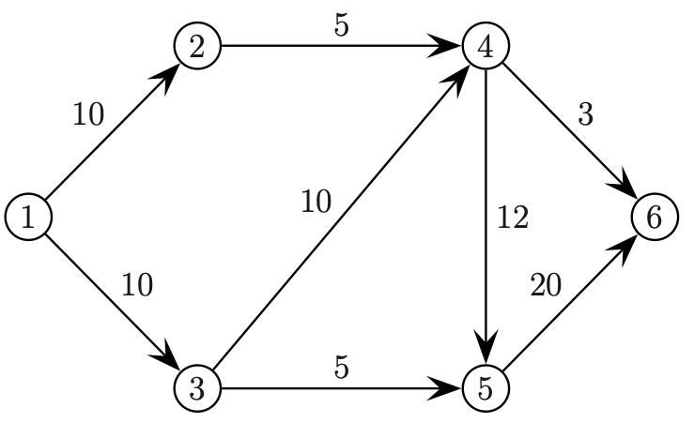

4. A unit-time task is a job, such as a program to be run on a computer, that requires exactly one unit of time to complete. Given a finite set S of unit-time tasks, a schedule for S is a permutation of S specifying the order in which to perform these tasks. The first task in the schedule begins at time 0 and finishes at time 1, the second task begins at time 1 and finishes at time 2, and so on.

The problem of scheduling unit-time tasks with deadlines and penalties for a single processor has the following inputs:

- a set S = {a₁, a₂,….,a_{n}} of n unit-time tasks;
- a set of n integer deadlines d₁, d₂,…., d_{n}, such that each d_{i} satisfies 1<=d_{i}<=n
and task a_{i} is supposed to finish by time d_{i}; and
- a set of n nonnegative weights or penalties w₁, w₂,…., w_{n}, such that we incur
a penalty of w_{i} if task a_{i} is not finished by time d_{i}, and we incur no penalty if
a task finishes by its deadline.

a_{i} | 1 | 2 | 3 | 4 | 5 | 6 | 7
d_{i} | 4 | 2 | 4 | 3 | 1 | 4 | 6
w_{i} | 70 | 60 | 50 | 40 | 30 | 20 | 10

Consider the above table. Propose a greedy algorithm and use that to find a schedule for S that minimizes the total penalty incurred for missed deadlines. [5 points]

5. In the weighted graph from the figure below, find the sequence of edge weights
selected when:

Dijkstra’s algorithm is run (r is the start vertex). [4 points]

